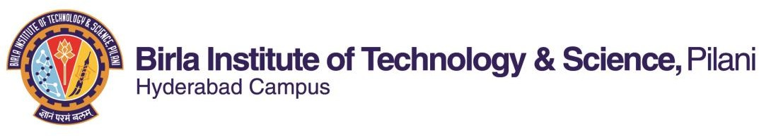

**SECOND SEMESTER 2020-2021**

**Course Handout (Part-II)**

**Date: 16.01.2021**

In addition to part-I (General Handout for all courses appended to the timetable) this portion gives further specific details regarding the course.

# Course No. : BIOT F422

**Course Title : Nanobiotechnology Instructors : Suman Kapur**

1. **Course Description:**

Introduction; Nanoscience in Nature; Fundamental science behind nanomaterials; Synthesis and properties of nanomaterials; Tools to study the properties, Size and Shape determinations, Application of nanomaterials in Science, Engineering and biomedical field; Future Trends.

# Scope & Objectives:

This is a course for the science and engineering students to introduce the concept of Nanobiotechnology at a basic level. It shows that nanomaterials are there in nature in abundance. Proper appreciation and unfolding them can lead to various fruitful application in Sciences, as well as in Engineering and Biomedical fields. The various techniques (conventional and ultra-modern) to synthesize and study nanomaterials are covered. The course ends with the direction towards which the field of Nanobiotechnology is growing at the moment.

# Text Book:

Nicolini, Claudio, Nanobiotechnology and nanobiosciences -- 2009, World Scientific Pub

# Reference Books:

RB1. C. M. Niemeyer and Chad A. Mirkin, Nanobiotechnology: concepts, applications and perspectives applications and perspectives, 2004, Wiley India

RB 2. Balaji, Subbiah, Nanobiotechnology, 2010*,* MJ Publisher India

# Lecture Plan:

|  |  |  |  |
| --- | --- | --- | --- |
| **Lect. No.** | **Learning Objectives** | **Topics to be covered** | **Chapter in the Text Book** |
| 1-3 | Introduction | What is Nanoscience? Where and how does the size matter? Moore’s Law, Nanoscience in  nature | TB Ch 1 |
| 4-10 | Some Basics of Solid  State Physics & Quantum Mechanics | Lattice Structure, Band Diagram, Density of States at various dimensions | TB Ch 1 & 3 |
| 11-18 | Fabrication of Nanoparticles Quantum wells wires  and dots | Top-down and bottom up approach | TB Ch 1 & 2 |

|  |  |  |  |
| --- | --- | --- | --- |
| 19-28 | Characterization and analysis | Scanning Tunneling microscopy, Scanning Probe Microscopy, X-ray & Neutron Scattering  Techniques | TB Ch 2, 3  & 4 |
| 29-34 | Properties of different  nanomaterials | Thermo-mechanical, Optical, Electrical,  Magnetic Properties | TB Ch 3 &  4 |
| 35-40 | Application of  nanoscience in various fields | Molecular Electronics, Nanostructured  materials, Polymer nancomposites, Nanobiology | Ch 4 |
| 40-42 | Future Trends | Future Scope of Nanoscience and a step  forward to a more powerful Nanotechnology | Research  articles |

1. **Evaluation Scheme:**

|  |  |  |  |  |  |
| --- | --- | --- | --- | --- | --- |
| **EC**  **No.** | **Evaluation Component** | **Duration** | **Weightage** | **Date and Time** | **Nature of Component** |
| 1 | Mid Sem Test | 90 min. | 30% | 03/03 3.30 - 5.00PM | Open Book |
| 2 | Quiz | Variable | 20% (4x5) | In class hours | Open Book |
| 3 | Assignments | Variable | 15% (3x5) | In class hours | Open Book |
| 4 | Comprehensive  Examination | 2 Hours. | 35% | 08/05 FN | Open book |

**Chamber Consultation Hour:** To be announced in the class.

**Notices:** Notices concerning the course will be put up on the notice board of Department of Biological Sciences

**Make-up policy:** Make-up decisions will be made on a case-by-case basis and only genuine cases as determined by the instructor and validated by Wardens and/or Medical Officer will be considered. No make-up for Quizzes/Presentations/Assignments.

**Academic Honesty and Integrity Policy:** Academic honesty and integrity are to be maintained by all the students throughout the semester and no type of academic dishonesty is acceptable.

Instructor-in-charge BIO F422